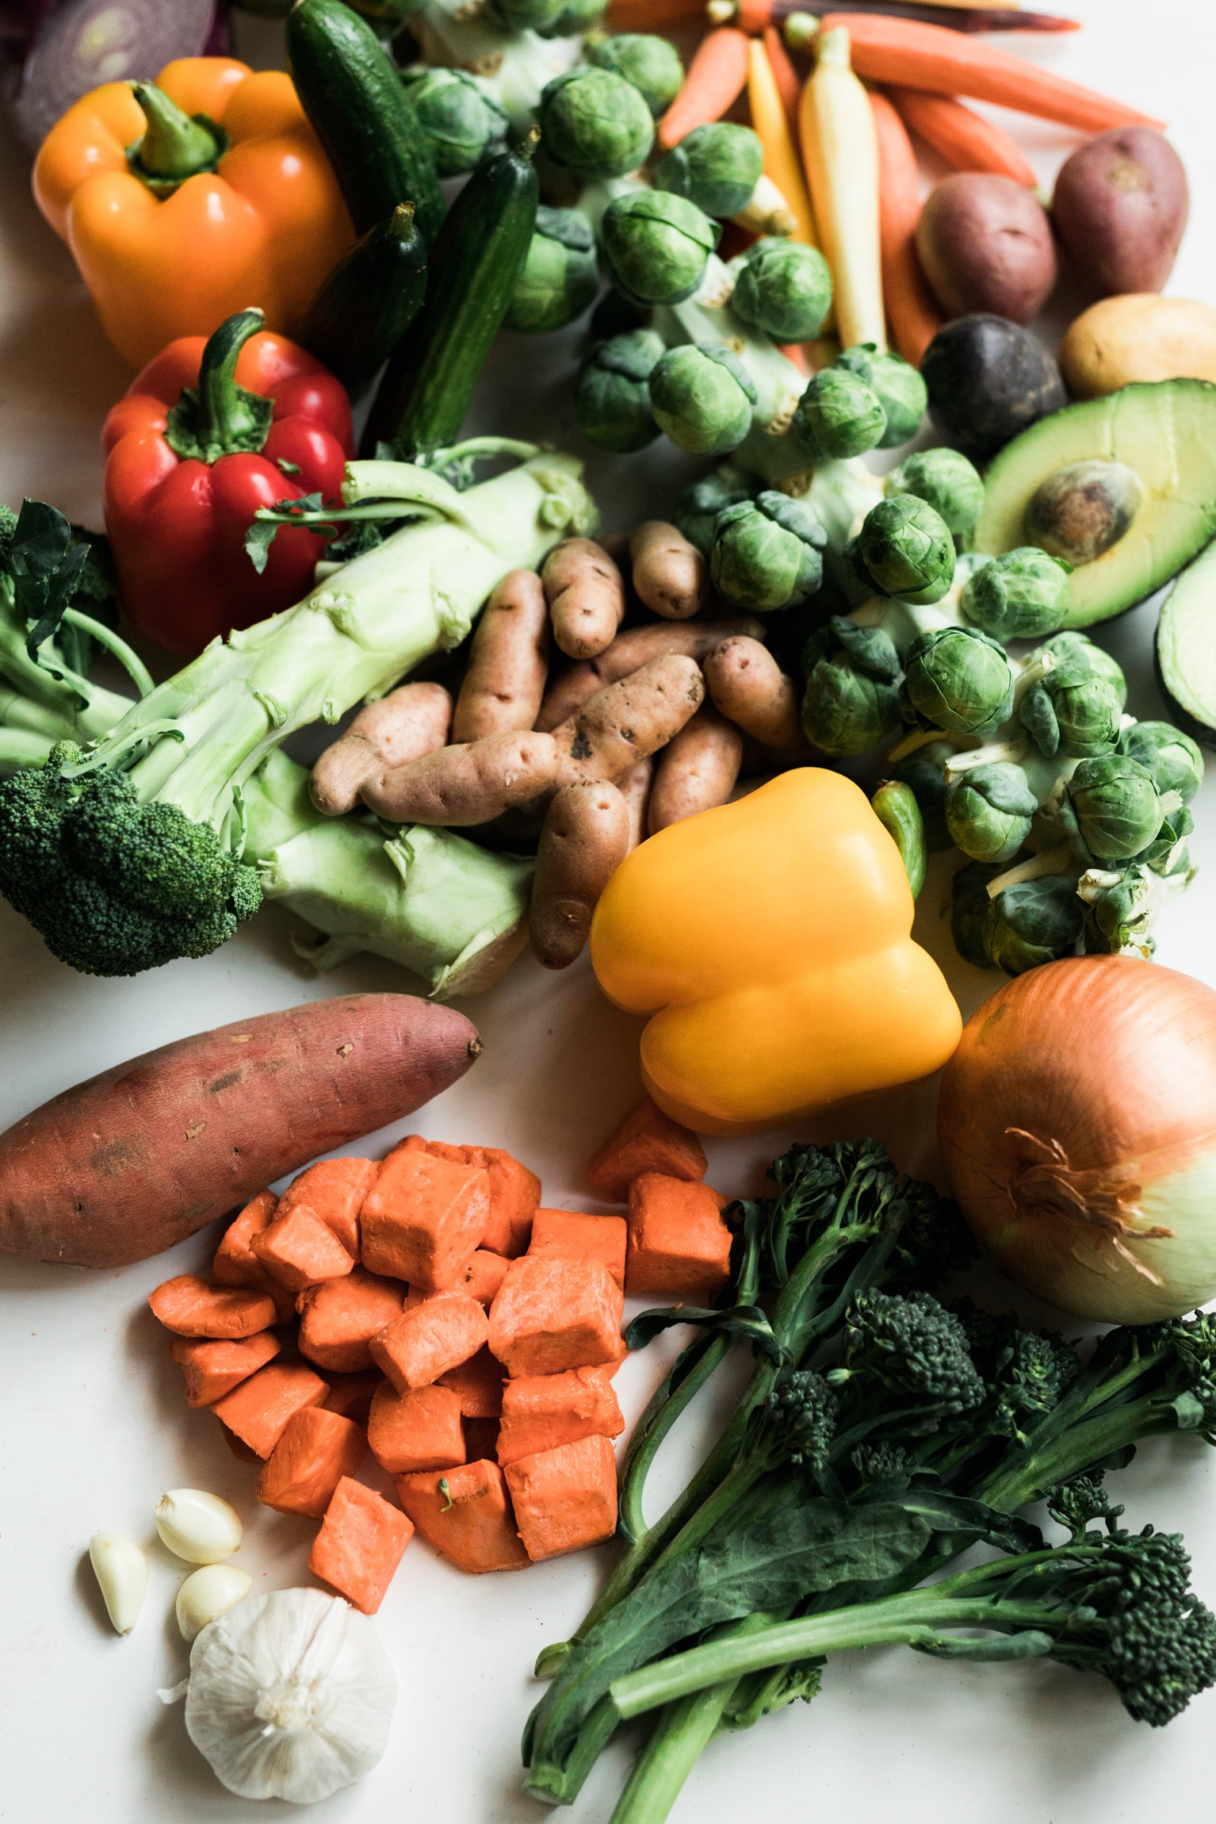

**SHOP the TRUCK!**

The Maryland Food Bank Eastern Shore’s **MOBILE MARKET** is visiting!   
We’re inviting ALL to receive healthy foods and resources.

Hop on board and shop the truck, fresh groceries and dry goods will be offered.

**Thursday October 10th**

**12:00pm – 2:00pm (or until done)**

Somerset County Library, (Crisfield Location)

100 Collins Street, Crisfield MD

***Free Food***

***Free Resources***Delivering Hope to Our Neighbors